January 2025
 |  |  |  |  |  | 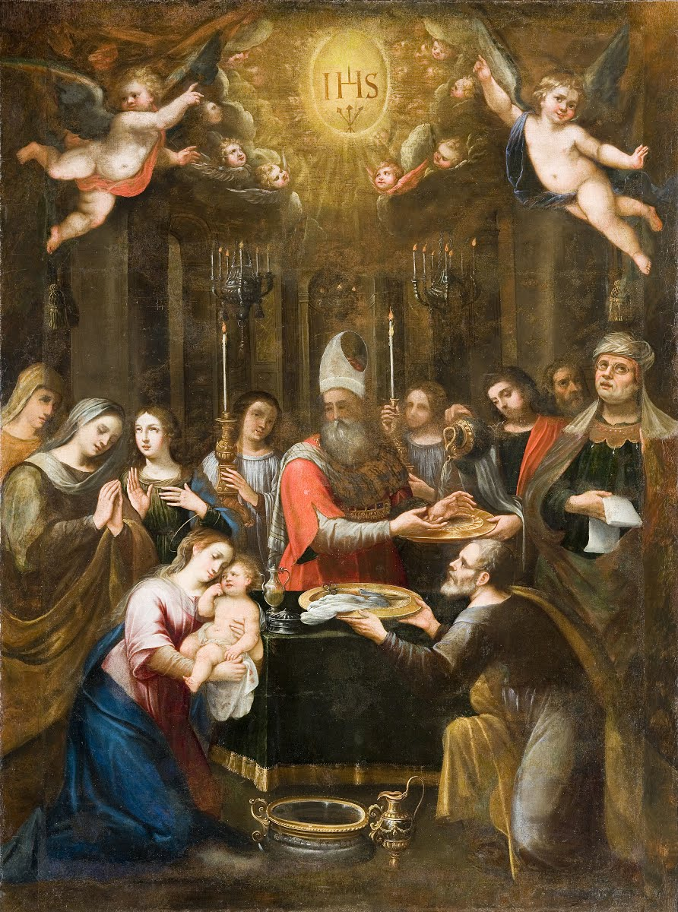
Now before faith came, we were held captive under the law, imprisoned until the coming faith would be revealed. So then, the law was our guardian until Christ came, in order that we might be justified by faith. ²⁵ But now that faith has come, we are no longer under a guardian, for in Christ Jesus you are all sons of God, through faith. For as many of you as were baptized into Christ have put on Christ. There is neither Jew nor Greek, there is neither slave^{[a]} nor free, there is no male and female, for you are all one in Christ Jesus. And if you are Christ's, then you are Abraham's offspring, heirs according to promise. Galatians 3:23-29
And at the end of eight days, when he was circumcised, he was called Jesus, the name given by the angel before he was conceived in the womb. Luke 2:21
Sunday |  | Monday | Tuesday | Wednesday | Thursday |  | Friday | Saturday
 |  |  | Dec. 31, 2023 | January 1 | 2 |  | 3 | 4
**Note: jan 7, call church if you are helping and what your bringing |  | Cs | Cs ½ day  EVE OF THE CIRCUMCISION AND NAME OF JESUS (NEW YEAR’S EVE | ncs  Happy New Year!!!  CIRCUMCISION AND NAME OF JESUS | cs
5 |  | 6 | 7 | 8 | 9 |  | 10 | 11
2nd Sunday after Christmas  Bible Stud 10:15 am  Sun. School10:15am  Worship 11:15 am  Acolyte – Christine |  | THE EPIPHANY OF OUR LORD | cs  **Taking down the Christmas trees  11:00 am  Help needed;  pot luck lunch. | cs | cs |  |  | Ladies of Grace Meeting @ 9::30 am
12 |  | 13 | 14 | 15 | 16 |  | 17 | 18
The baptism of our lord / first Sunday after the epiphany  Bible Stud  10:15 am  Sun. School 10:15am  Worship 11:15 am  Acolyte –Christine  VOTERS MTG |  |  | cs  Quilting 9:30 am | cs | cs
19 |  | 20 | 21 | 22 | 23 |  | 24 | 25
Second Sunday after the epiphany  Bible Stud 10:15 am  Sun. School10:15am  Worship 11:15 am  Acolyte –Christine |  |  | cs | cs | cs
26 |  | 27 | 28 | 29 | 30 |  | 31
Third Sunday after the epiphany  Bible Stud 10:15 am  Sun. School10:15am  Worship 11:15 am  Acolyte – Christine |  |  | cs | cs | cs |  | Decorating for private event on Feb 1. | Cs – church Secretary in  Ncs Church Secretary NOT in on that day* but subject to change.

